



Newsletter 2023 September-December

**CINEC Convocation 2023: The Day Graduates became Graduands**

A campus convocation is an awe-inspiring and bittersweet event; graduands are draped in their academic regalia, proudly showing the world that they are now more than ready for the challenges of the world outside of the campus, all the while saying goodbye to friends, lecturers, and a campus life that has become an inseparable part of their lives for 3 or 4 years.

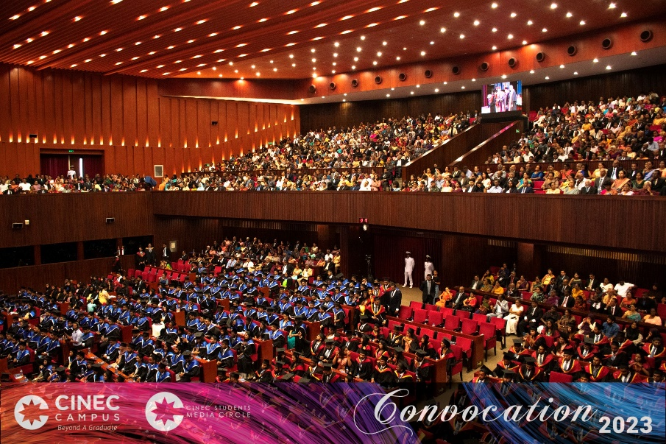The annual convocation ceremony of CINEC Campus was held in three sessions at the Main Conference Hall of BMICH with a participation of over 4000 on the 31st of October 2023. A record number of 1200 graduates physically participated and received their Postgraduate and Undergraduate Degrees, Advanced Diplomas and Diplomas respectively in the fields of Maritime Science, Marine Engineering, Marine Electrical Engineering, Engineering & Technology, Information Technology, Management and Social Sciences, Logistics and Transport, Health Sciences, Aviation, English Language and Teacher Training programmes conducted at the CINEC Campus in Malabe and the Metro Campus in Nugegoda. The balance received their respective qualification in absentia.

Capt. Ajith Peiris, President of CINEC Campus made the keynote speech and Chancellor of CINEC and delegates of affiliated universities from UK and China conferred degrees and higher diplomas. Special awards for outstanding students were given away by the Senior Management, Board of Directors of CINEC Campus and special invitees. The scale and the diversity of the spectrum of much desired, quality higher education that had been accomplished by CINEC over last 33 years and the high standards maintained at the convocation earned high praise and admiration of all distinguished invitees, parents, graduates and well-wishers.

**Special award winners**

**Faculty of Health Sciences**

* Best Overall Performance - Higher Diploma in Biomedical Sciences - PERERA G.C.A.

• Best Research - BSc (Hons) Industrial Pharmaceutical Sciences - Nethmi Thara Thotawatte

• Best Research - BSc (Hons) Biomedical Sciences - Nipuni Thilakshani Rathnayaka.

* Best Academic Achievement - BSc (Hons) Industrial Pharmaceutical Sciences - Nethmi Thara Thotawatte
* Best Academic Achievement - BSc (Hons) Biomedical Sciences - Harindi Nayanathara Devagiri

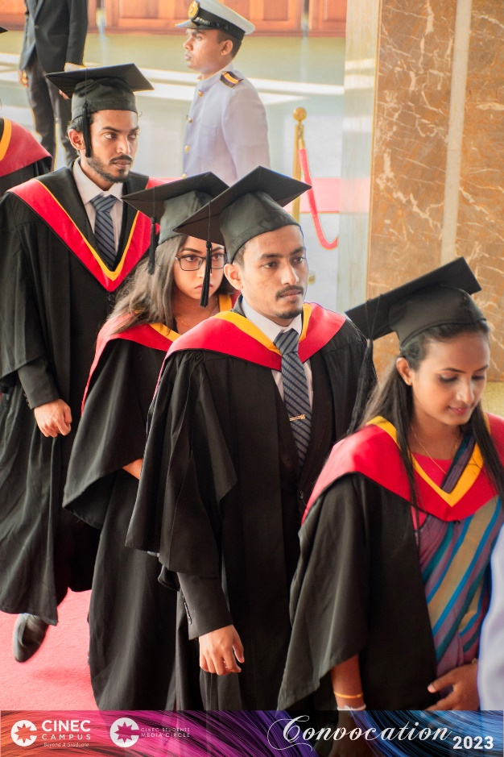

**Faculty of Engineering and Technology**

* Best Individual Research Project - BSc (Hons) in Engineering in Civil Engineering - Pushparaj Dilukshan

• Best Individual Research Project - BSc (Hons) in Engineering in Automotive Engineering - Rathnayake Mudiyanselage Thiwanka Priyashan

• Best Individual Research Project - BSc (Hons) in Engineering in Electronic & Telecommunication Engineering - Rupasinghe Arachchige Pubudu Sandakalum Rupasinghe

• Best Individual Research Project - BSc (Hons) in Engineering in Mechanical Engineering - Dinuka Nisal Thanaweera Achchige

• Best Dissertation - Bachelor of Science (Hons) Computer Science (Software Engineering) - Balasuriya Arachchige Jehan Sanju Balasuriya

• Best Dissertation - BSc (Hons) Computer Networks – Senarath Rathnayaka Kusal Geesuru

• Best Dissertation - Bachelor of Engineering (Hons) in Mechatronics Engineering - Wadiya Ralalage Sudeera Milakshan

• Best Dissertation - Master of Engineering (Honours) in Electronic and Telecommunications Engineering - Ahangama Gamage Thimali Geshani Kulatunga

* Best Academic Achievement - Bachelor of Science (Hons) Computer Science (Software Engineering) - Jayakodi Arachchilage Thulanjana Pramod Amarasinghe
* Best Academic Achievement - BSc (Hons) Computer Networks – Rajapaksha Pathirannahalage Malith Praveen Rajapaksha
* Best Overall Performance - BSc (Hons) in Engineering in Electronic & Telecommunication Engineering - Handun Pathirannehelage Hiruni Navoda Sandun Pathirana
* Best Academic Achievement - Bachelor of Engineering (Honours) in Mechatronics Engineering - Wadiya Ralalage Sudeera Milakshan
* Best Academic Achievement - Master of Engineering (Hons) in Mechatronics Engineering - Dasanayaka Aluthge Oshadhi Rangika
* Best Overall Performance - Pearson BTEC Higher National Diploma in Computing - Galbokka Hewage Chamod Ayeshchariya
* Best Overall Performance - Pearson BTEC Higher National Diploma in Computing - Warnakulasuriya Mahathelge Harshani Navishka Peiris
* 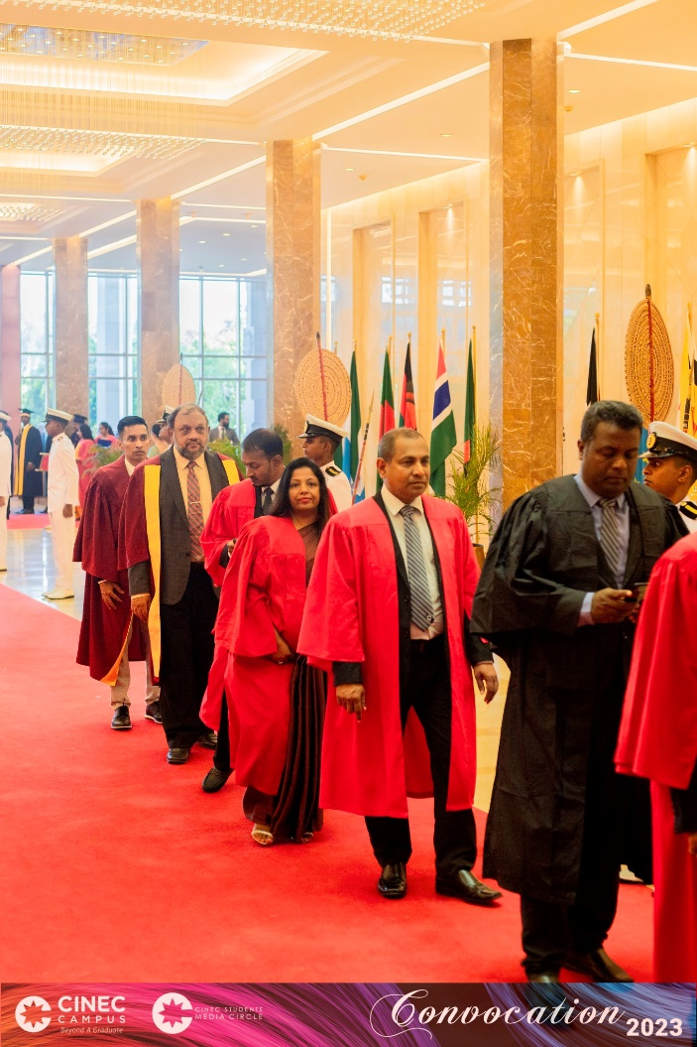Best Overall Performance - Pearson BTEC Higher National Diploma in Construction & the Built Environment (Civil Engineering) - Bopakada Arawe Gedara Damith Eranga Lakshan
* Best Overall Performance - Pearson BTEC Higher National Diploma in Mechanical Engineering - Michel Banuka Kapuruge
* Best Overall Performance - Pearson BTEC Higher National Diploma in Electrical & Electronic Engineering - Warnakulasooriya Metiasge Chrishani Rosa Obris

**Faculty of Humanities and Education**

* Best Overall Performance - Diploma in Teaching English Language and Literature - Zainab Aysha Marikar
* Best Overall Performance - Diploma in Primary Teaching - Balapuwaduge Melissa Venuri Mendis
* Best Overall Performance - Diploma in Teaching Mathematics and Science - Maneesha Rochani Dissanayake Bulner
* Best Overall Performance - Diploma in Early Childhood Education - Balapuwaduge Rukmali Niroshini Mendis
* Best Overall Performance - Jaffna Branch - Diploma in Primary Teaching - Punitharaj Piriyanthy

• Best Dissertation - Bachelor of Education (Hons) in Information Technology - Bendarage Dona Ridmi Anjalika

• Best Dissertation - Bachelor of Education (Hons) in Information Technology - Wickrama Arachchi Kankanamge Nadeera Lakshika

* Best Dissertation - Bachelor of Arts (Hons) in English - Jayasekara Kaththotaralalage Dinithi Supunika Jayasekara

• Best Dissertation - Bachelor of Arts (Hons) in English - Shayanne Rebecca Nicholas

• Best Academic Achievement - Bachelor of Education (Hons) in Information Technology - Wickrama Arachchi Kankanamge Nadeera Lakshika

• Best Academic Achievement - Bachelor of Arts in English - Mahapatuna Vithanage Tharusha Perera

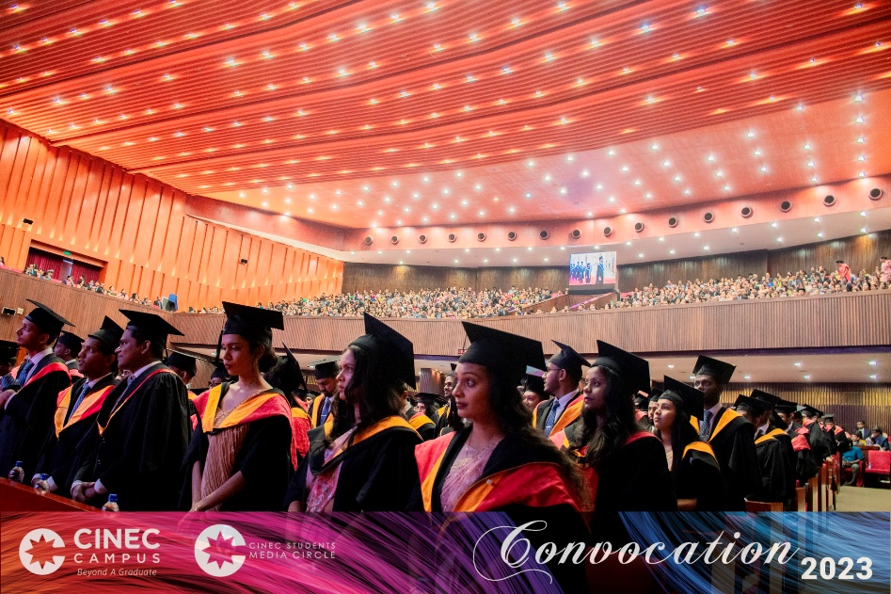

• Best Academic Achievement - Bachelor of Arts (Hons) in English - Jayasekara Kaththotaralalage Dinithi Supunika Jayasekara

**Faculty of Management and Social Sciences**

* Best Research - Bachelor of Management (Hons) in Retail Marketing and Branding - Egoda Rajage Ayesh Uditha Saranga
* Best Research - Bachelor of Management (Hons) in Tourism and Hospitality Management (Travels and Events Specialization) - Marieza Shehari De Almeida
* Best Research - Bachelor of Management (Hons) in Tourism and Hospitality Management (Cruise Tourism Specialization) - Pasindu Keshara Ranasinghe
* 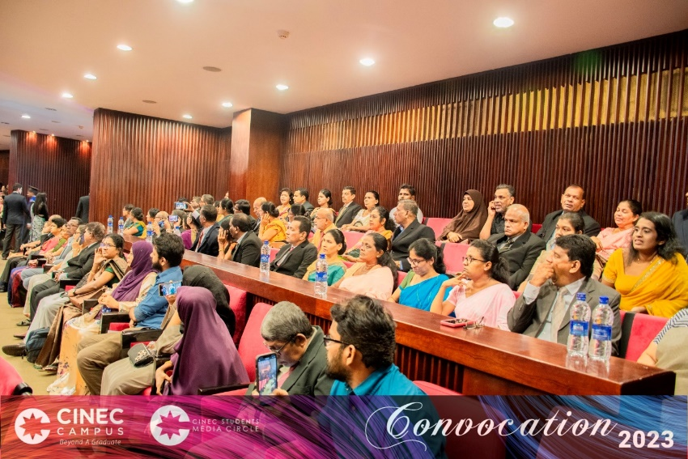Best Research - Bachelor of Management (Hons) in Supply Chain Management - Dinith Ishan Habaragamuwa
* Best Research - Bachelor of Science (Hons) Logistics & Transportation - Ranawakachchi Kankanamge Jithma Oshadee Ranawake
* Best Research - BSc in International Transportation Management and Logistics - Hiruni Poornima Maheepala
* Best Academic Achievement - Bachelor of Management (Hons) in Retail Marketing and Branding - Egoda Rajage Ayesh Uditha Saranga
* Best Academic Achievement - Bachelor of Management (Hons) in Tourism and Hospitality Management (Cruise Tourism Specialization) - Yagama Sachini Imalka Senarathne
* Best Academic Achievement - Bachelor of Management (Hons) in Tourism and Hospitality Management (Travels and Events Specialization) - Hetti Arachchilage Don Megha Lakmali Weerasinghe
* Best Academic Achievement - Bachelor of Management (Hons) in Supply Chain Management - Umesha Hansani Wijesinghe
* Best Academic Achievement - Bachelor of Science (Hons) Logistics & Transportation - Mathugamage Dona Sajani Nisansa

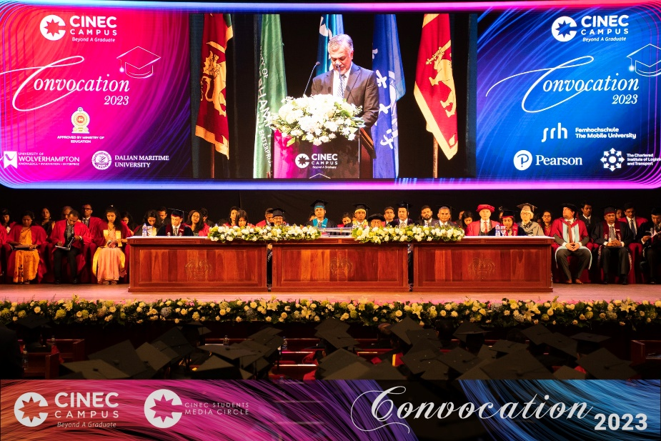

* Best Academic Achievement - BSc in International Transportation Management and Logistics - Hiruni Poornima Maheepala
* Best Overall Performance - Professional Diploma in Logistics and Supply Chain Management - Senarath Mudalige Udesha Lakmali
* Best Overall Performance - Professional Diploma in Shipping Management - Karagoda Loku Gamage Dulashi Vidushika Deshani
* Best Overall Performance - CILT Diploma International Diploma in Logistics and Transport - Chathurya Samarasinghe
* Best Overall Performance - CILT International Advanced Diploma in Logistics and Transport - Dishan Nimrod Isaac
* 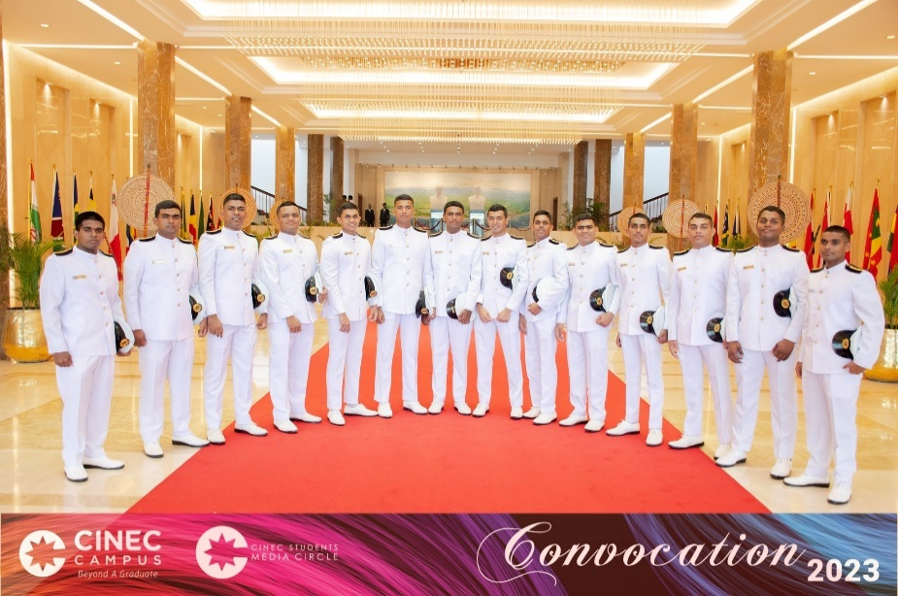Best Academic Achievement - Master of Business Administration (Batch 09) - Samarasinghe C. L.
* Best Academic Achievement - Master of Business Administration (Batch 10) - De Silva E.S.K
* Best Academic Achievement - Master of Business Administration (Batch 11) - Abeykoon P. R. B.

**Faculty of Maritime Sciences**

* Excellence in Seamanship - Officer Cadet - Maritime Sciences - Wickramarachchige Don Imesh Anjana Kumarasinghe
* Excellence in Navigation - Officer Cadet - Maritime Sciences - Wellappuli Arachchige Sasindu Hasaranga
* Best All-Round Navigation Cadet - Tharindu Lakmina Jayasinghe

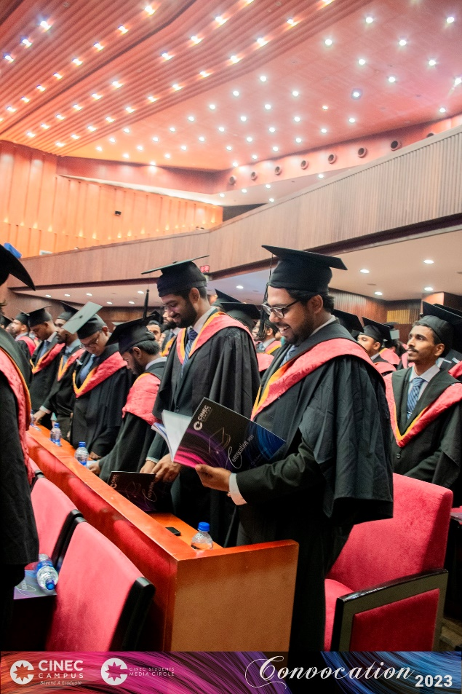**Faculty of Marine Engineering**

* Excellence in Marine Engineering Knowledge - Officer Cadet - Marine Engineering (BATCH 43)- Induwara Rathnaweera Undugoda
* Excellence in Workshop Theory and Practice - Officer Cadet - Marine Engineering (BATCH 43) – Naveen Avishka Undugoda
* Best Marine Engineering Cadet (BATCH 43) – Naveen Avishka Undugoda
* Excellence in Electrical Engineering Knowledge - Officer Cadet - Marine Electro Technical - Minod Eshan Samarasekara
* Excellence in Electrical Workshop Practice - Officer Cadet - Marine Electro Technical - Thiththalapitige Pubudu Harshana Peiris
* Best all-Round Marine Electro Technical - Weligampola Gedara Nuwan Dananjaya Rajapaksha
* Excellence in Marine Engineering Knowledge - Officer Cadet - Marine Engineering (BATCH 44)- Don Tharusha Jalana Gunawardena
* Excellence in Workshop Theory and Practice - Officer Cadet - Marine Engineering (BATCH 44) – Don Tharusha Jalana Gunawardena
* Best Marine Engineering Cadet (BATCH 44) - Edirisinghe Galappaththige Bashana Pahan Edirisinghe
* Best Academic Achievement - Higher Diploma in Aircraft Maintenance Engineering - Unanthenna Oshan Imalka

**CINEC BRANCH NEWS**

Newsletter 2023 September-December

**Fiji Maritime Academy**

The Fiji Maritime Academy (FMA) stands as a pillar of success for CINEC’s ventures overseas. Established initially in 1970 by expatriates of Fiji, the FMA, was a renowned institution in its heyday. However, due to political unrest, the academy failed to sustain the glory it once had. In 2014, the government of Fiji called upon Sri Lanka’s aid in bringing Fiji Maritime Academy up to standard and CINEC undertook that challenging task.

That CINEC was able to fulfill the task it was given successfully is a fact to be happy and proud of. After its turnover, the Fiji Maritime Academy went onto become the first ISO certified education centers in the entirety of Fiji. As of 2016, the FMA has helped 300 seafarers to comply with the STCW Manilla Conventions and has garnered attention from other nations of the region. This is mostly due to the innovative simulator training courses it provides. Some of them include the Electronic Chart Display (ECD), Bridge, and Engine.

As of 2023, the FMA has taken a step into the global pursuit of gender equality, and ultimately into the future, by integrating Fijian female seafarers into the academy. The academy has also included the Chartered Institute of International Logistics & Transport (CLIT) program, which is a highly esteemed certification endorsed by the University of Gloucestershire and the Peninsula College.

Newsletter 2023 September-Decemberember

**White** **Coat Ceremony 2023**

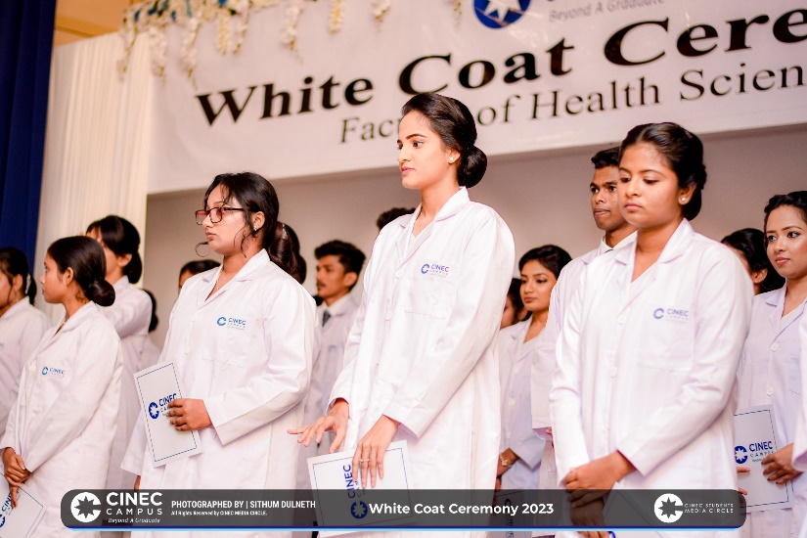The White Coat Ceremony for the year 2023 at CINEC Campus, Malabe, took place with splendor in the campus auditorium on the 6th of October, marking the commencement of a promising journey for future scientists and scholars.

This significant event was diligently organized by Batch 6 degree students and Batch 2 higher diploma students in the Faculty of Health Science. Distinguished attendees included President Capt. Ajith Pieris, Senior Consultant Admiral Thisara Samarasinghe, Senior Consultant Professor Veranja Karunaratne, Vice President Ms. Tharanga Gamage, Vice President Captain Peshala Medagama, Dean of Faculty of Health Science Senior Professor Menik Hettihewa, Deans from other faculties, esteemed lecturers, faculty members, and the students.

The ceremony unfolded with the rendition of the CINEC anthem and the traditional lighting of the oil lamp. Mas. Sathsara Liyana-Arachchi, the former batch representative of the 6th batch, warmly welcomed the gathering. Impactful speeches were delivered by Senior Consultant Admiral Thisara Samarasinghe, Senior Professor Manik Hettihewa, and senior lecturer Capt. Prasanna Sedrick.

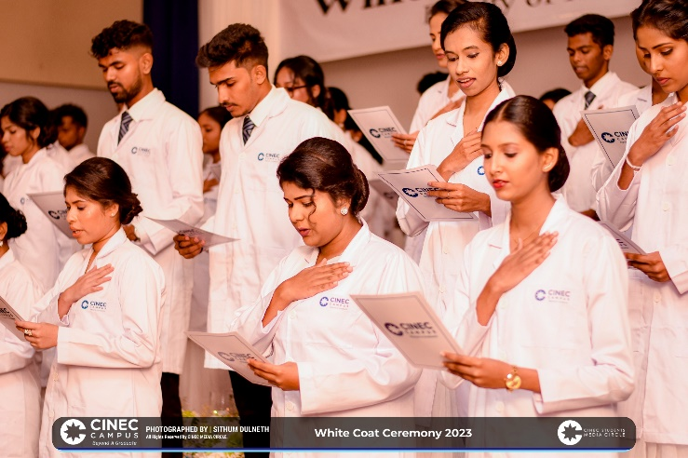The symbolic movement of the event arrived as senior professor Menik Hettihewa, along with the academic staff, bestowed white coats upon one hundred and thirty-four degree and higher diploma expectants specializing in Biomedical Science, Industrial Pharmaceutical Science, and Cosmeceutical Science. Each student, upon receiving the white coat, took a solemn oath to perform and serve with utmost respect, commitment, dignity, and honesty, thereby contributing to the well-being of society and the advancement of science.

The culmination of this memorable day featured the vote of thanks delivered by former batch representative, Ms. Yashoda Mithrarathne, followed by the rendition of the national anthem, leaving an indelible mark on the hearts of all who attended.

**Knuckles Leadership Program**

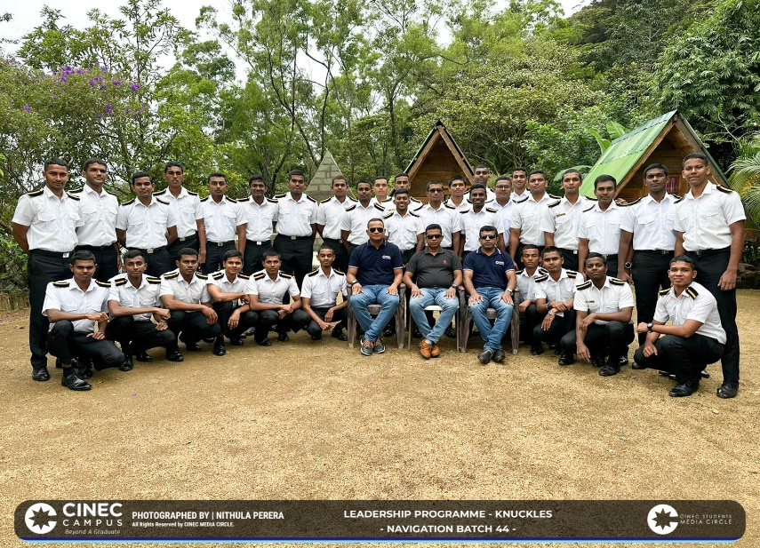

A leadership program for the cadets of the 44th Navigation Batch was held in the Knuckles Mountain range on October 7th to 9th. Their foray into the Knuckles landscape was organized in order to empower them to be future leaders and teach them valuable lessons in teamwork. The program had them participating in leadership skill development activities and observing the natural landscape of the mountain range.

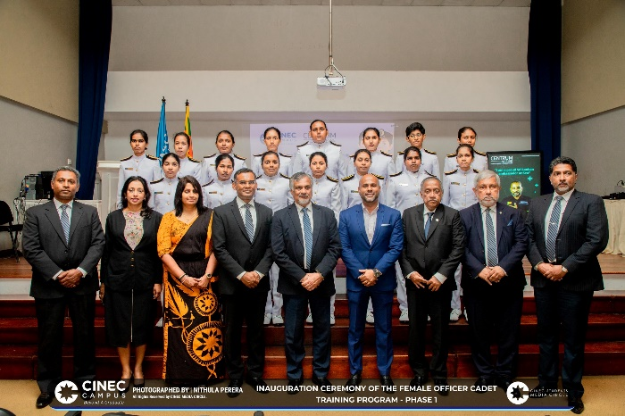**Programs Catering to Female Officer Cadets Implemented at CINEC**

Further establishing its prestige and adding a momentous event to their history books, CINEC Campus has given a great opportunity for ladies to join its accredited and prestigious officer cadet ranks, with the aim of lessening the gender gap and providing equal opportunities being the forefront thought of this significant decision.

In conversation with Mr. Nuwan Danthanarayana, a credited lecturer, simulator instructor, and Officer in charge of cadets, the reason to begin training female cadets stem from the current high demands from the industry for lady officers. He further mentions that there have been a couple of lady cadets trained before, but not as a complete batch. Then the idea arose to give the necessary training to an entire batch, paving the way for them to join the ever-growing industry. With the current high demand and the ever-increasing number of lady officers training and overseeing duties on ships, why not create a pathway for Sri Lankan ladies who are intent on pursuing a career in the field? This was considered the foremost reason for establishing this.

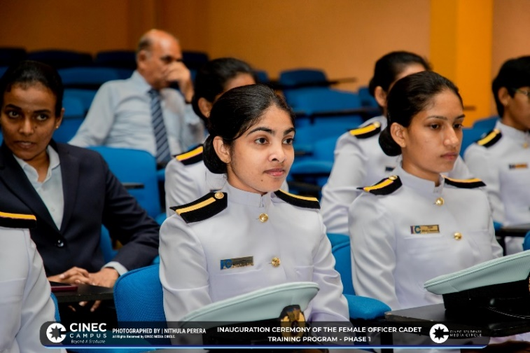With the opportunity created, Mr. Danthanarayana foresees a great deal of positive changes and contributions that can be made by training female officer cadets. With a fair number of vacancies opening up for female officers in the trade, the influx of foreign revenue into the country will be able to boost the country’s economy. It is anticipated that CINEC Campus will be able to produce quite a number of female officer cadets in the future, further establishing its prestige. With world-class training on par with international standards, it is highly expected that these ladies will reach great heights in the industry.

This decision is not without its challenges and there were some that needed to be overcome. Initially, finding placements on board vessels was a challenge encountered but with the current demand for lady officers that challenge has been addressed. In addition, convincing the ladies to join the ranks and their parents to let their daughters into the program has also been a challenge, but it is quite reasonable to claim that this too has been overcome.

An inaugural seminar took place on September 2nd, 2023 at the CINEC Auditorium for the implementation of the female officer cadets’ program quite successfully, along with Minister Susil Premajayantha’s visit to the campus will provide a greater insight to the audience present. A batch of seventeen, of whom six will train as engineering cadets, nine as navigational officers and two as foundation cadets, is expected to begin their program on November 24th, 2023.

Mr. Danthanarayana would like to emphasize the fact that everyone would get the same training without any difference or discrimination. He requested that the rest of the student body treat them with respect and not look down on them in any way.

Newsletter 2023 September-Decemberember

**Delegates of Nordic Hamburg Crewing Services Visit CINEC**

Mr. Marc Schmidt, Managing Director and Ms. Olga Pavlova, Crewing Manager of Nordic Hamburg Crewing Services GmbH visited CINEC on Friday 17th of November 2023 from 09.00 a.m. to 02.30 p.m.

**Capt. Gayan Gunawardena Passes Away**

Capt. Gayan Gunawardena, Director, Ceyline Shipping Ltd., passed away unexpectedly on the 12th November, 2023. The final rites were performed in the Jayarathne VIP parlor on the 13th November 2023 and he was laid to rest in the Borella cemetery. May he attain the supreme bliss of Nibbana.

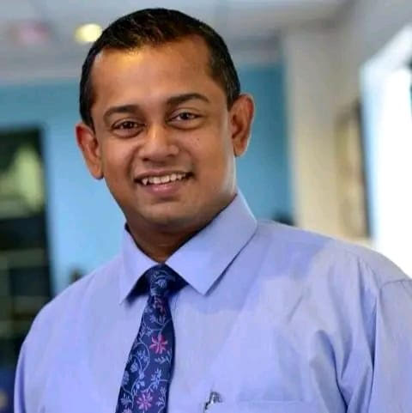

Newsletter 2023 September-Decemberember

**Zero Plastic Unit Established at CINEC**

A new Zero Plastic Unit was established at CINEC Campus on October 11th 2023 at CINEC Campus.

Their first project was held on November 9th 2023. It was a cleanup project in collaboration with the London Stock Exchange Group, Malabe to clean the Chandrika Kumaratunga Mawatha.

**CSMC Competitor Wins 2nd Place at Mora Lenz**

Nadee Balasooriya of the CINEC Students’ Media Circle won 2nd place in the University category of the English announcing competitions at the Mora Lenz Media Awards. It was organized by the Mass Media Club of the University of Moratuwa on September 16th 2023 at the university premises.

Sawinde Weerasinghe and Chamalka Senevirathne of the CINEC Students’ Media Circle were also rewarded as the top 10 finalists of the English announcing and Sinhala announcing categories, respectively.

**Not All Heroes Wear Capes: CINEC Blood Donation Campaign 2023**

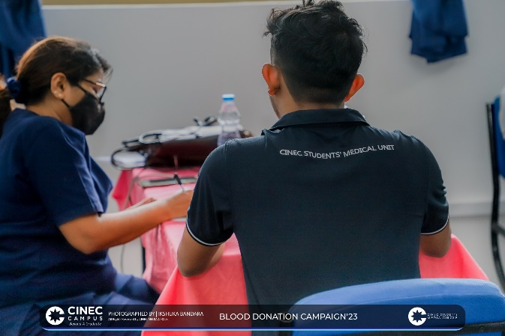True heroes can also appear in the form of thriving youngsters who play a significant role in contributing to the enhancement of a society. Proving further on this note, the Students Medical Unit of CINEC Campus, along with the assistance of Apeksha Hospital, Maharagama, and Sri Jayawardenepura Hospital, organized a blood donation campaign that was conducted at the campus premises on September 1, 2023.

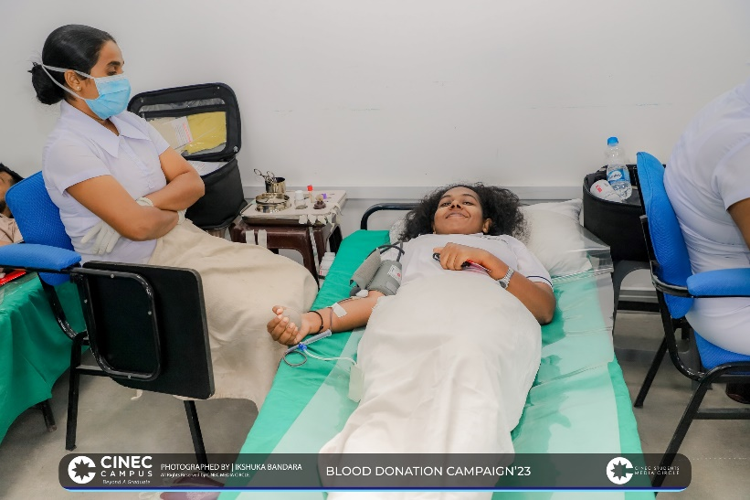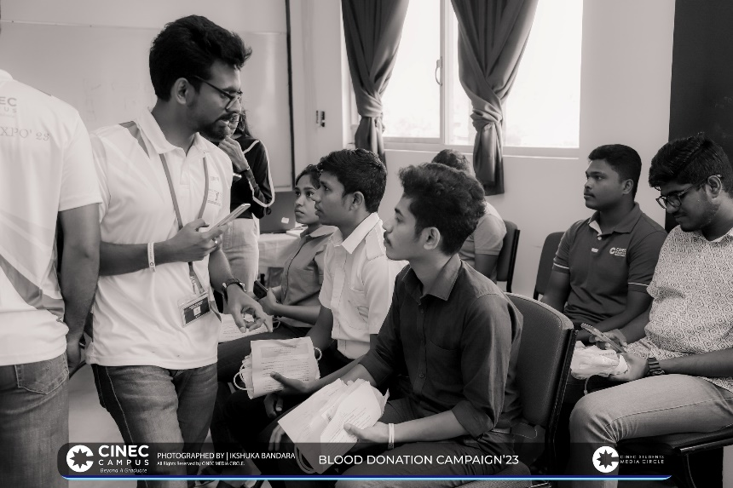 The objective of providing a sufficient amount of blood donations in order to finalize the stocks of the Blood Bank peaked into succession with a total of 156 blood bags, furnished by both the academic and non-academic staff of the campus. It was, in fact, a promising accomplishment owing to the diligence of many individuals, comprising the former student director of CINEC Students’ Medical Unit Jayod Kushmantha, Capt. Peshala Medagama, Prof. Menik Hettihewa, Dr. Vishmi Perera, Ms. Nethmini Paramanayaka, Mr. Thimira Pasas, and Mr. Nalin Samarasinghe. Not to mention the exceptional accompaniment of the CINEC Students’ Association and the CINEC Students’ Media Circle, which scoured the evet to triumph. Namely, it was one of the largest projects orchestrated by the campus, and thereby gained quite a recognition than of the first blood donation project in 2022. However, the blood, sweat, and tears of heroes-sans-spotlights engraved a greater benevolence on society.

**CINEC Carols 2023 Concludes the Year with Christmas Cheer**

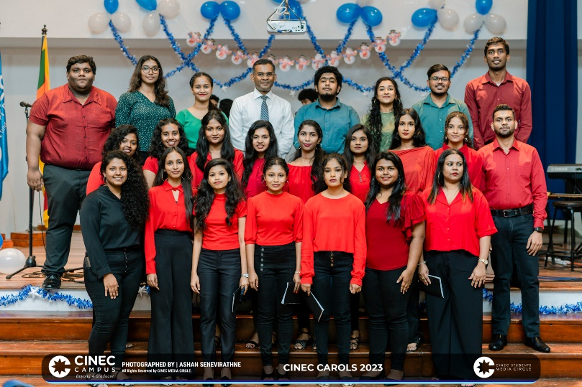In accordance with tradition, the Aesthetic Circle of the CINEC Students Association organized a Christmas Carol performance on December 21st, 2023. The choir comprised of almost thirty student singers and the music was provided by CINEC Campus’ very own CINEC Navigators band. The choir and instrumentalists were directed and conducted by main female vocalist for the Navigators, Raneesha Rajapaksha.

**Annual General Meeting of CINEC Students’ Media Circle**

The Annual General Meeting of the CINEC Students’ Media Circle for the year 2023 was held on December 19th, 2023. It was hosted in order to review the activities organized and covered by the Media Circle during the entirety of the year. One of the aims of the meeting was also to reveal the name of the Media Day project the CSMC will be organizing in 2024, Vistara. The meeting concluded on a high note with hopes for the future blazing bright.

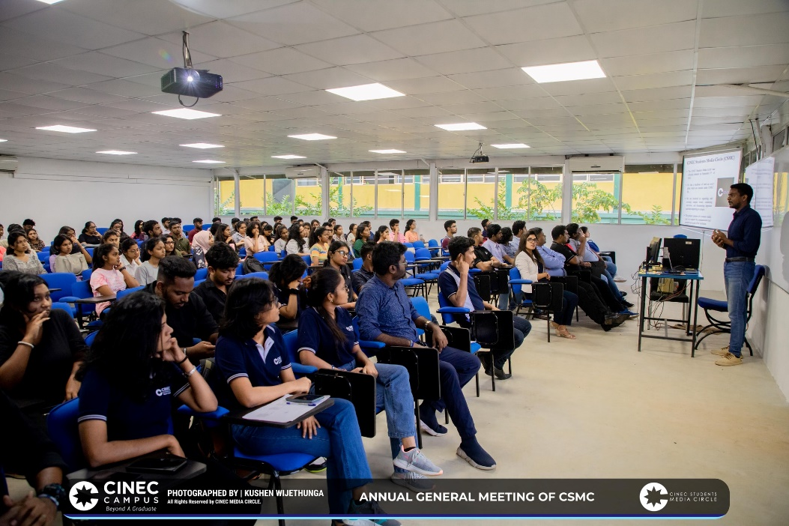

**Waithala’23: CINEC Mariners Shine in an Unprecedented Musical Extravaganza**

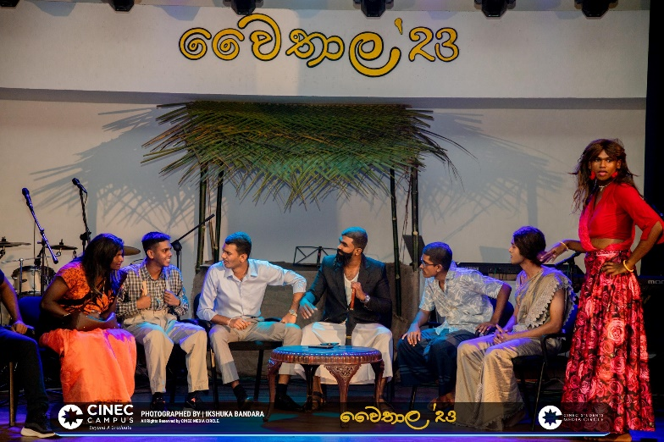The musical event titled Waithala’23, organized by the Maritime students of CINEC Campus, was held in a grand manner on December 06th, 2023. It turned out to be an event unlike anything the CINEC community has ever seen in the institution’s long history.

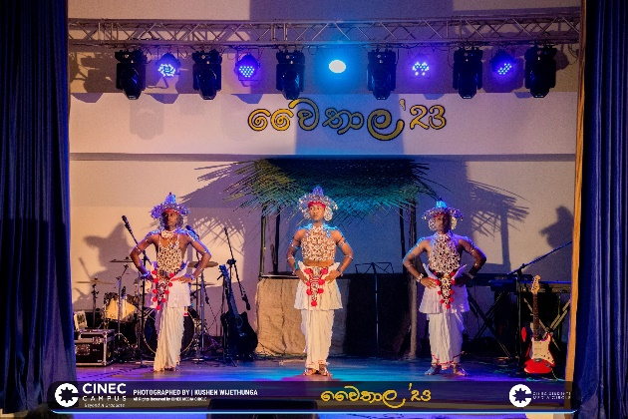

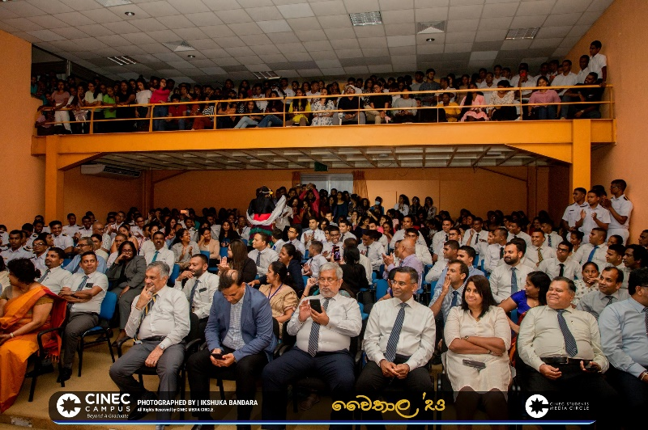

**CINEC Dreamers Win Tantalize’23**

CINEC Campus’ very own band, Dreamers, were able to obtain victory in the Bands and Instrumentals Category at Tantalize 2023 organized by APIIT Campus. Our heartfelt congratulations go to the talented instrumentalists and vocalists of the band.

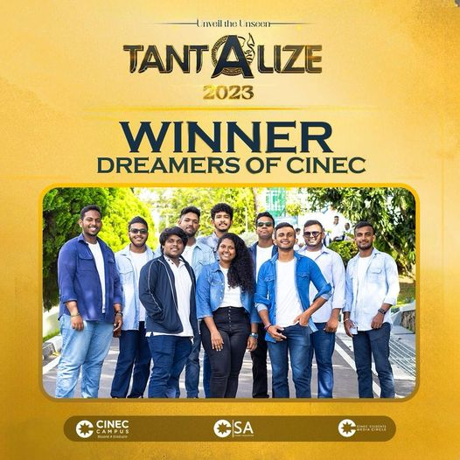



Newsletter 2023 September-Decemberember

**CINEC Sports Dominates in NSBM U-Sports Championships 2023**

In September 2023, several sports clubs from CINEC Campus participated in the inter-university sports championships organized by NSBM. The games attracted a lot of attention in the sports calendar of CINEC due to the impressive achievements and perfomances of CINEC’s athletes, who emerges victorious in various events.

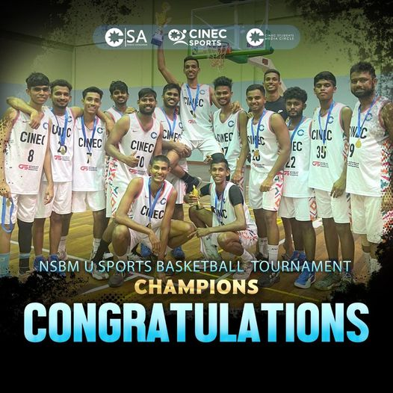The basketball tournament ended with the CINEC Basketball team emerging victorious with a final score of 56:52 against NSBM University. Two members of the CINEC team were also recognized for their outstanding performances on the court. Krishan Denver Pieris was awarded the “Most Valuable Player of the Tournament” for his remarkable contributions, while Salin Udayanga received the “Best Defensive Player” award for his crucial role in the team’s path to victory.

The rugby team of CINEC emerged as champions of the tournament, defeating NSBM University 21:7 in the finals. Kaveen Manditha was recognized as the Player of the Tournament.

Both the Netball and Table Tennis teams of CINEC competed with great spirit and secured positions in the championships. The Netball team achieved the position of 3rd Runners Up, thanks to their amazing teamwork and perseverance. The Table Tennis team also secured a bronze medal in the tournament for the first time, highlighting their exceptional skills and dedication.

The CINEC Hockey team has had a successful debut month, securing positions and earning the title of 1st Runners Up in the tournament. Goalkeeper Avinda Kaushan was also recognized for his outstanding performance, receiving the award for “Best Goalkeeper.” This achievement once again highlights the team’s exceptional skills and expertise in the sport.

**CINEC Sports Shines at APIIT Extravaganza 2023**

The 9th episode of APIIT Extravaganza, the biggest sports encounter among state and non-state universities, was hosted by the Students’ Activity Club of the Asia Pacific Institute of Information Technology (APIIT). The competition served as a platform for athletes of varying sports to display their talents and sportsmanship, including badminton, cricket, swimming, basketball, rugby, and futsal. The event commenced on August 25th and raged for six weeks, concluding on October 15th.

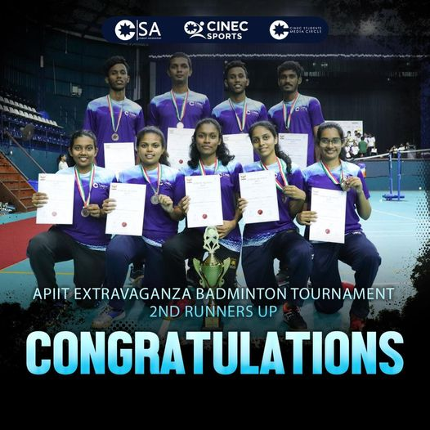The badminton team of CINEC that participated in the Extravaganza emerged victorious by securing 3rd place amongst the other universities. We, at CINEC, send forth our warmest wishes and congratulations to the badminton team for elevating the pride, honor, and glory of the campus.

**Achieving camaraderie and celebrating unity with the FHS Premier League**

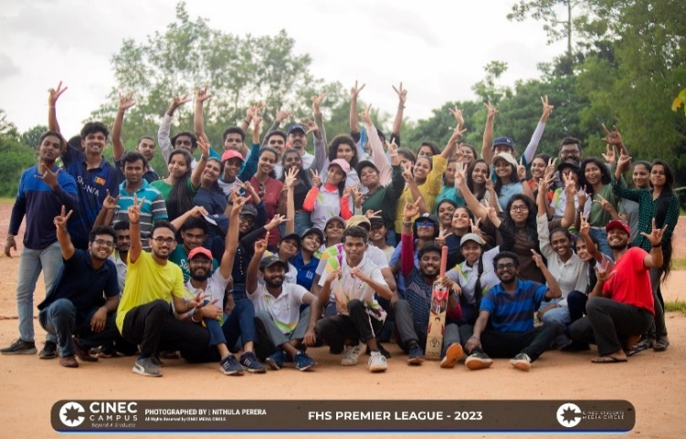

Organized by the Faculty of Health Science, the cricket tournament was a spell that promoted unity as well as a platform that provided with a valuable opportunity to showcase talents and skills. The tournament was held on October 22 at the Bomiriya Central College Ground.

Six teams that represented three variations of the health science batches played in the tournament. The teams were the Thunder Strikers, the Red Dragons, the Vikings, the Falcons, the Sky Guardians and the Legendary Knights.

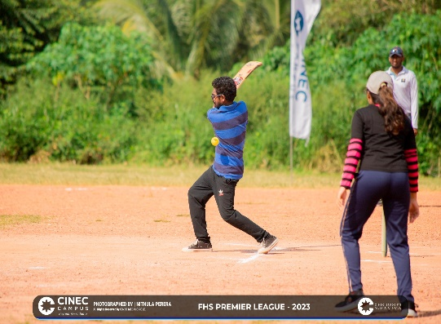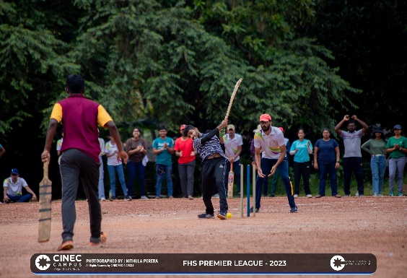With a true display of sportsmanship and an excellence in talent and coordination, the team of Thunder Strikers paved the way to be crowned as the winners of the tournament.

The culmination of the cricket league, the awards for the best batsman and best baller were awarded to the well-deserved students of Kalhan and Lakruwan respectively. Abilashini was crowned as the best female player of the tournament.

The following parties are greatly acknowledged for their support in providing news and pictures.

CHIEF EDITOR: Chandrawansha, P. Sandamali.

EDITORIAL PANEL:

1. Sawinde, W.M.
2. Balasuriya, D.N.A.

STUDENT WRITERS:

1. Jayathma, K.H.D.
2. Fonseka, H.A.R.N.
3. Rubasinghe, S.M.
4. Baduge, P.S.A.
5. Asokan, T.L.

GRAPHIC DESIGNERS:

1. Sawinde, W.M.

All photos featured in the newsletter are the property of the respective photographers, including, but not limited to, the CINEC Students’ Media Circle.

CINEC Campus in Malabe is the publisher of this newsletter. Please contact us using the provided information if you have news, a story, or any other suggestions for how we can enhance the Newsletter.